COINS-EUR-Greece-Athens-Athena Eule-Tetradrachm Silver- 440-404 BCE

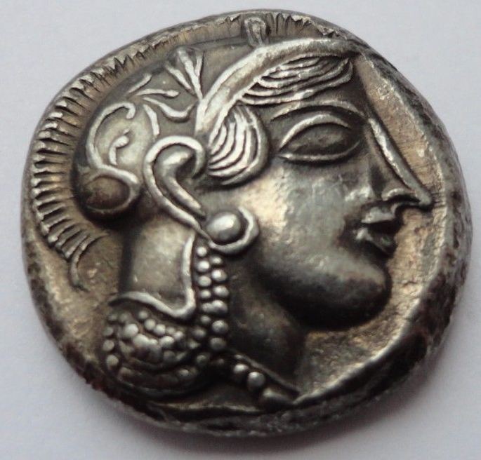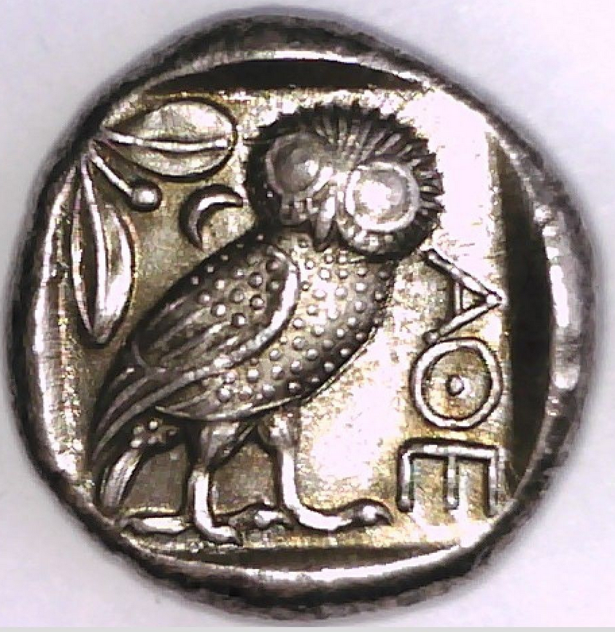

Greece-Athens-Athena Eule-Tetradrachm Silver- 440-404 BCE, Head of Goddess Athena, wearing Corinthian helmet, right Rev. Owl standing

**Case no.: Coins**

**Accession Number:**

**Formal Label:**

Greece-Athens-Athena Eule-Tetradrachm Silver- 440-404 BCE, Head of Goddess Athena, wearing Corinthian helmet, right Rev. Owl standing

**Display Description:**

Head of Athena right, wearing crested attic helmet ornamented with three laurel leaves and vine scroll. AOE owl standing right, head facing, olive sprig and crescent moon behind, all within incuse square.

**LC Classification: CJ317.U62**

**Date or Time Horizon:** 440 – 404 BCE

**Geographical Area:** Athens

**Map:**

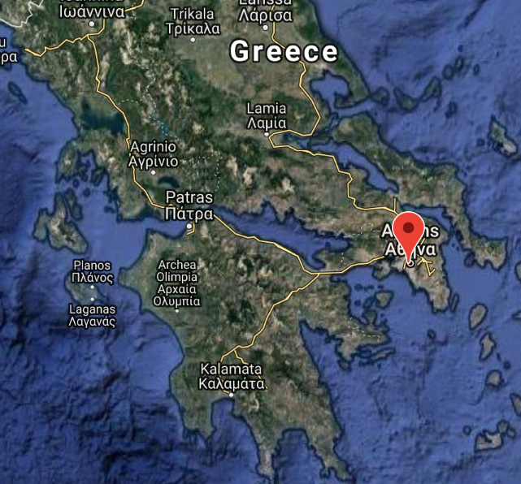

**Location of Athens. After https://gps-coordinates.org/athens-latitude.php**

**GPS coordinates:**

Latitude: 37.9838096

Longitude: 23.727538800000048

**Cultural Affiliation:** Classical Athens

**Medium:** silver

**Dimensions:** Diameter: 25mm.

**Weight:**

**Condition:**

**Provenance:**

**Discussion:**

**References:**

Daehn, William E. [2001] *Ancient Greek numismatics: a guide to reading and research : a bibliography of works written in English with summaries of their contents*. Cold Spring, MN : Davissons Ltd.,

Franke, Peter Robert. [1964] *Die griechische Münze [von] Peter R. Franke [und] Max Hirmer. Aufnahmen von Max Hirmer.* München, Hirmer.

Waggoner, Nancy. 1983. *Early Greek coins from the collection of Jonathan P. Rosen***.** New York: American Numismatic Society.

|  |
| --- |
|  |
|  |